Assignment No: - 6

**Title: -** Mining Puzzles

**Aim and Objective: -** Demonstrate how mining take place in blockchain and how node are supposed to solve the Mining puzzle.

**Theory: -**

**Blockchain nodes and their types**

A node is a computer that runs blockchain software and helps transmit the information across the blockchain network. Laptop, phone, router, etc. are all nodes. Anyone can download blockchain software and run it for free. Nodes are classified into different types based on their role in the blockchain.

* Mining Nodes (also called miners): These are the nodes that can add transactions to a blockchain. Every node in the blockchain network has an option to become a mining node. The process of adding transactions to a blockchain is called mining.

**How can a miner solve the puzzle?**

As illustrated in the picture below and explained in my other [article](https://medium.com/swlh/blockchain-characteristics-and-its-suitability-as-a-technical-solution-bd65fc2c1ad1?source=friends_link&sk=9a7333bd5010463171584370dbf7b719), a block in a blockchain has the following key components: header, data, nonce, previous hash, and hash. Data is a set of transactions, hash is a unique identifier for a block and is analogous to a fingerprint for a human, previous hash is the hash value of the previous block in the blockchain, Nonce, and header has the details such as block number, timestamp, etc.

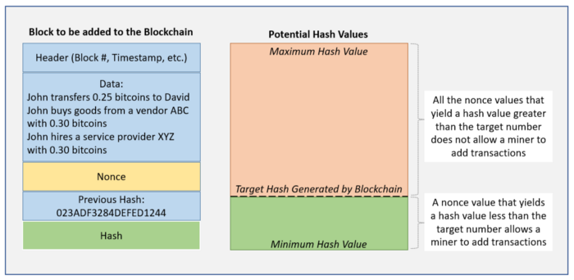

Blockchain program creates a complex puzzle for the miners which is to generate a “Nonce” value which when combined with the other components in the block (i.e., header, data, previous hash) and passed through a hash function, produces a hash value that is less than a target hash value. In the case of bitcoin, the nonce is an integer between 0 and 4,294,967,296.

*Hash = function (header, data, nonce, previous hash)*

The mining node that solves the puzzle first, distributes its blockchain and informs the rest of the nodes in the network so that the other miners can stop working on that block and move onto finding the “Nonce” for a different block. Blockchain program performs a series of checks to determine whether the block should be added to the blockchain or not. Once all the checks are passed, block is added to the blockchain and copied to all the nodes in the network. The miner receives new bitcoins as a reward for its work.

**Code: -**

**Output: -**

**Conclusion: -**

I successfully Implement Mining puzzle and demonstrated it